END SEMESTER ASSIGNMENT OF
C PROGRAMMING

PRESENTED BY:-
MANTAVYA KUMAR(25BECCS43)
ANKIT KUMAR SOLET(25BECCS13)
NEHA KUMARI(25BECCS50)
SHIVAM KUMAR BHANDARI(25BECCS67)
DEPARTMENT: COMPUTER SCIENCE AND
ENGINEERING
COURSE: B.TECH
SEMESTER:01

PROBLEM 1:Create a structure to specify data of customers in a bank. The data to be stored is: Account number, Name, Balance in account. Assume maximum of 200 customers in the bank.
(a) Write a function to print the Account number and name of each customer with balance below Rs. 100.
(b) If a customer request for withdrawal or deposit, it is given in the form: Acct. now, amount, code (1 for deposit, 0 for withdrawal)
(c)Write a program to give a message, “The balance is insufficient for the specified withdrawal”.
SOLUTION:
#include <stdio.h>
#include <string.h>

#define MAX_CUSTOMERS 200

// Structure to store customer data
struct Customer {
int accountNumber;
char name[50];
float balance;
};

// Function to print customers with balance below Rs. 100
void printLowBalanceCustomers(struct Customer customers[], int n) {
printf("\nCustomers with balance below Rs. 100:\n");
for (int i = 0; i < n; i++) {
if (customers[i].balance < 100) {
printf("Account No: %d, Name: %s\n", customers[i].accountNumber, customers[i].name);
}
}
}

// Function to process deposit/withdrawal
void processTransaction(struct Customer customers[], int n, int acctNo, float amount, int code) {
int found = 0;
for (int i = 0; i < n; i++) {
if (customers[i].accountNumber == acctNo) {
found = 1;
if (code == 1) { // Deposit
customers[i].balance += amount;
printf("Deposit successful. New balance: %.2f\n", customers[i].balance);
} else if (code == 0) { // Withdrawal
if (customers[i].balance >= amount) {
customers[i].balance -= amount;
printf("Withdrawal successful. New balance: %.2f\n", customers[i].balance);
} else {
printf("The balance is insufficient for the specified withdrawal.\n");
}
} else {
printf("Invalid transaction code.\n");
}
break;
}
}
if (!found) {
printf("Account number %d not found.\n", acctNo);
}
}

int main() {
struct Customer customers[MAX_CUSTOMERS];
int n;

printf("Enter number of customers (max %d): ", MAX_CUSTOMERS);
scanf("%d", &n);

for (int i = 0; i < n; i++) {
printf("\nEnter details for customer %d:\n", i + 1);
printf("Account Number: ");
scanf("%d", &customers[i].accountNumber);
printf("Name: ");
scanf("%s", customers[i].name);
printf("Balance: ");
scanf("%f", &customers[i].balance);
}

// (a) Print customers with balance below Rs. 100
printLowBalanceCustomers(customers, n);

// (b) Transaction example
int acctNo, code;
float amount;
printf("\nEnter transaction details:\n");
printf("Account Number: ");
scanf("%d", &acctNo);
printf("Amount: ");
scanf("%f", &amount);
printf("Code (1 for deposit, 0 for withdrawal): ");
scanf("%d", &code);

processTransaction(customers, n, acctNo, amount, code);

return 0;
}
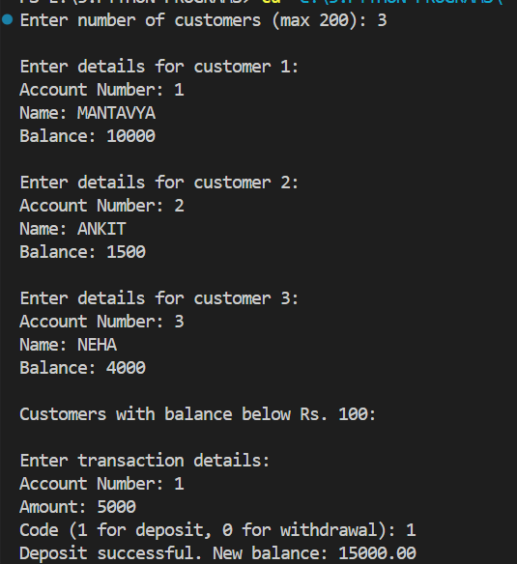

Problem 2: In a college database system, it is important to maintain details of students in a structured and organized way. Using a structure in C, we can group related data (like roll number, name, course, and marks) into a single unit for easier access and management. You are required to develop a C program to manage and process student data using structures. Write a C program that performs the following operations using structures:
1. Define a structure named Student with the following members: o int rollNo o char name [50] o char course [30] o float marks
2. Accept details of N students (where N is entered by the user).
3. Display all student details in a well-formatted table.
4. Find and display the student who has the highest marks.
5. Search for a student by roll number and display their details if found.
6. Calculate the average marks of the class

SOLUTION:
#include <stdio.h>
#include <string.h>

// Step 1: Define Student structure
struct Student {
int rollNo;
char name[50];
char course[30];
float marks;
};

// Function to display all students in a table
void displayStudents(struct Student students[], int n) {
printf("\n%-10s %-20s %-15s %-10s\n", "Roll No", "Name", "Course", "Marks");
printf("---------------------------------------------------------------\n");
for (int i = 0; i < n; i++) {
printf("%-10d %-20s %-15s %-10.2f\n",
students[i].rollNo,
students[i].name,
students[i].course,
students[i].marks);
}
}

// Function to find student with highest marks
void highestMarks(struct Student students[], int n) {
int maxIndex = 0;
for (int i = 1; i < n; i++) {
if (students[i].marks > students[maxIndex].marks) {
maxIndex = i;
}
}
printf("\nStudent with highest marks:\n");
printf("Roll No: %d, Name: %s, Course: %s, Marks: %.2f\n",
students[maxIndex].rollNo,
students[maxIndex].name,
students[maxIndex].course,
students[maxIndex].marks);
}

// Function to search student by roll number
void searchByRoll(struct Student students[], int n, int roll) {
int found = 0;
for (int i = 0; i < n; i++) {
if (students[i].rollNo == roll) {
found = 1;
printf("\nStudent found:\n");
printf("Roll No: %d, Name: %s, Course: %s, Marks: %.2f\n",
students[i].rollNo,
students[i].name,
students[i].course,
students[i].marks);
break;
}
}
if (!found) {
printf("\nNo student found with Roll No %d\n", roll);
}
}

// Function to calculate average marks
void averageMarks(struct Student students[], int n) {
float sum = 0;
for (int i = 0; i < n; i++) {
sum += students[i].marks;
}
printf("\nAverage marks of the class: %.2f\n", sum / n);
}

int main() {
int n;
printf("Enter number of students: ");
scanf("%d", &n);

struct Student students[n];

// Step 2: Accept student details
for (int i = 0; i < n; i++) {
printf("\nEnter details for student %d:\n", i + 1);
printf("Roll No: ");
scanf("%d", &students[i].rollNo);
printf("Name: ");
scanf("%s", students[i].name);
printf("Course: ");
scanf("%s", students[i].course);
printf("Marks: ");
scanf("%f", &students[i].marks);
}

// Step 3: Display all students
displayStudents(students, n);

// Step 4: Find student with highest marks
highestMarks(students, n);

// Step 5: Search student by roll number
int roll;
printf("\nEnter roll number to search: ");
scanf("%d", &roll);
searchByRoll(students, n, roll);

// Step 6: Calculate average marks
averageMarks(students, n);

return 0;
}
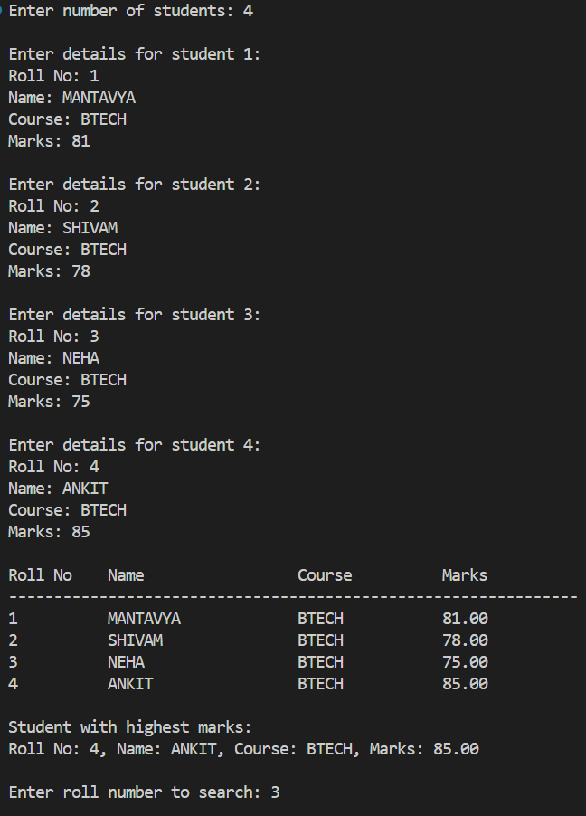

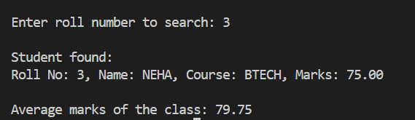
Problem 3: A local library wants to develop a simple digital record system to manage its book inventory. The system should allow adding new books, displaying all books, and creating a backup of the data. You are required to write a C program that performs these tasks using file handling concepts. Problem Statement: Write a C program to manage library book records using files. The program should perform the following operations:
- Add New Book Record:
o Accept details such as Book ID, Title, Author Name, and Price from the user
Store this data in a file named library.txt using append mode ("a"), so that new records can be added without overwriting existing ones.
- Display All Book Records:
o Read all records from library.txt using read mode ("r").
o Display them in a formatted manner (Book ID, Title, Author, Price).
3. Create a Backup File:
o Copy all contents from library.txt to another file named backup.txt using read ("r") and write ("w") modes.
o Display a message when the backup is successfully created.

SOLUTION:

#include <stdio.h>
#include <stdlib.h>

struct Book {
int bookID;
char title[50];
char author[50];
float price;
};

// Function to add new book record
void addBook() {
FILE *fp;
struct Book b;

fp = fopen("library.txt", "a"); // open in append mode
if (fp == NULL) {
printf("Error opening file!\n");
return;
}

printf("\nEnter Book ID: ");
scanf("%d", &b.bookID);
printf("Enter Title: ");
scanf("%s", b.title);
printf("Enter Author: ");
scanf("%s", b.author);
printf("Enter Price: ");
scanf("%f", &b.price);

// Write to file
fprintf(fp, "%d %s %s %.2f\n", b.bookID, b.title, b.author, b.price);

fclose(fp);
printf("Book record added successfully!\n");
}

// Function to display all book records
void displayBooks() {
FILE *fp;
struct Book b;

fp = fopen("library.txt", "r"); // open in read mode
if (fp == NULL) {
printf("No records found. File does not exist!\n");
return;
}
printf("\n%-10s %-20s %-20s %-10s\n", "BookID", "Title", "Author", "Price");
printf("---------------------------------------------------------------\n");

while (fscanf(fp, "%d %s %s %f", &b.bookID, b.title, b.author, &b.price) == 4) {
printf("%-10d %-20s %-20s %-10.2f\n", b.bookID, b.title, b.author, b.price);
}

fclose(fp);
}
// Function to create backup file
void createBackup() {
FILE *fp1, *fp2;
char ch;

fp1 = fopen("library.txt", "r");
if (fp1 == NULL) {
printf("No records found. Cannot create backup!\n");
return;
}

fp2 = fopen("backup.txt", "w");
if (fp2 == NULL) {
printf("Error creating backup file!\n");
fclose(fp1);
return;
}

while ((ch = fgetc(fp1)) != EOF) {
fputc(ch, fp2);
}

fclose(fp1);
fclose(fp2);

printf("Backup created successfully in backup.txt!\n");
}

int main() {
int choice;

do {
printf("\nLibrary Management System\n");
printf("1. Add New Book Record\n");
printf("2. Display All Book Records\n");
printf("3. Create Backup File\n");
printf("4. Exit\n");
printf("Enter your choice: ");
scanf("%d", &choice);

switch (choice) {
case 1:
addBook();
break;
case 2:
displayBooks();
break;
case 3:
createBackup();
break;
case 4:
printf("Exiting program...\n");
break;
default:
printf("Invalid choice! Try again.\n");
}
} while (choice != 4);

return 0;
}
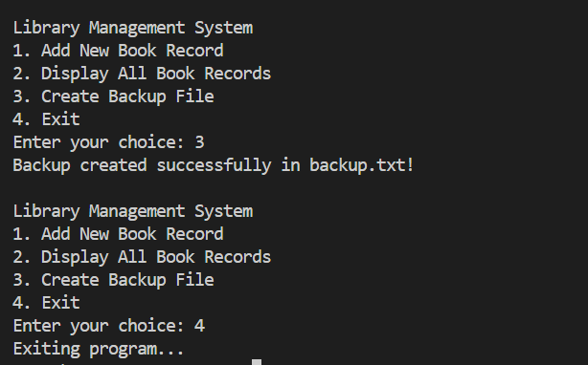

Problem 4: In many educational institutions, small-scale data management systems are required to maintain student records such as roll number, name, course, and marks. You are appointed as a C developer to build a console-based student record manager that uses file handling operations to store, retrieve, modify, and append student data using different file access modes. Your program should demonstrate all file modes (r, w, a, r+, w+, a+) in meaningful operations. Create a menu-driven C program named StudentRecordSystem.c that allows users to perform the following operations:
1. Create a New File of Records - Write Mode ("w"): Use this mode to create or overwrite a student database file named students.txt. Prompt the user to enter multiple student records, including: o Roll Number 3/3 o Name o Course o Marks • Use fprintf() to write data line by line into the file. • Inform the user that previous data (if any) will be deleted.
2. Display All Records - Read Mode ("r"): Use fopen() in "r" mode. Read and display all student records in a tabular format using fscanf() or fgets(). If the file doesn’t exist, display a suitable message: "No data found. Please create a file first."
3. Add New Records - Append Mode ("a"): Open the file in "a" mode to add new student entries without deleting old ones. Input new records and store them at the end of the existing file. Confirm with the message: "Record appended successfully."
4. Modify Existing Record - Read & Write Mode ("r+") : Use "r+" mode to read and update a specific student record. Search the record by Roll Number. If found, modify the record (e.g., update marks or course). Use rewind() or file pointer repositioning (fseek()) to overwrite data in place.
5. Recreate & Read Data - Write & Read Mode ("w+") : Use "w+" mode to clear all existing data and allow re-entry of records. After writing, use rewind() to move the pointer to the start. Display the newly entered records immediately on the console.
6. View and Add Records - Append & Read Mode ("a+"): Use "a+" mode to first display existing data, then add new records. After adding, again display the complete updated list of records. Use rewind() to read from the beginning after writing new data.
SOLUTION:
#include <stdio.h>
#include <stdlib.h>
#include <string.h>

struct Student {
int rollNo;
char name[50];
char course[30];
float marks;
};

// Function to create new file (w mode)
void createFile() {
FILE *fp = fopen("students.txt", "w");
if (fp == NULL) {
printf("Error creating file!\n");
return;
}
int n;
printf("Enter number of students: ");
scanf("%d", &n);

struct Student s;
for (int i = 0; i < n; i++) {
printf("\nEnter details for student %d:\n", i + 1);
printf("Roll No: "); scanf("%d", &s.rollNo);
printf("Name: "); scanf("%s", s.name);
printf("Course: "); scanf("%s", s.course);
printf("Marks: "); scanf("%f", &s.marks);

fprintf(fp, "%d %s %s %.2f\n", s.rollNo, s.name, s.course, s.marks);
}
fclose(fp);
printf("\nFile created successfully. Previous data (if any) deleted.\n");
}

// Function to display all records (r mode)
void displayRecords() {
FILE *fp = fopen("students.txt", "r");
if (fp == NULL) {
printf("\nNo data found. Please create a file first.\n");
return;
}
struct Student s;
printf("\n%-10s %-20s %-15s %-10s\n", "RollNo", "Name", "Course", "Marks");
printf("---------------------------------------------------------------\n");
while (fscanf(fp, "%d %s %s %f", &s.rollNo, s.name, s.course, &s.marks) == 4) {
printf("%-10d %-20s %-15s %-10.2f\n", s.rollNo, s.name, s.course, s.marks);
}
fclose(fp);
}

// Function to append new record (a mode)
void appendRecord() {
FILE *fp = fopen("students.txt", "a");
if (fp == NULL) {
printf("Error opening file!\n");
return;
}
struct Student s;
printf("\nEnter new student details:\n");
printf("Roll No: "); scanf("%d", &s.rollNo);
printf("Name: "); scanf("%s", s.name);
printf("Course: "); scanf("%s", s.course);
printf("Marks: "); scanf("%f", &s.marks);

fprintf(fp, "%d %s %s %.2f\n", s.rollNo, s.name, s.course, s.marks);
fclose(fp);
printf("Record appended successfully.\n");
}

// Function to modify record (r+ mode)
void modifyRecord() {
FILE *fp = fopen("students.txt", "r+");
if (fp == NULL) {
printf("No data found. Please create a file first.\n");
return;
}
int roll;
printf("Enter roll number to modify: ");
scanf("%d", &roll);

struct Student s;
long pos;
int found = 0;

while ((pos = ftell(fp)), fscanf(fp, "%d %s %s %f", &s.rollNo, s.name, s.course, &s.marks) == 4) {
if (s.rollNo == roll) {
found = 1;
printf("Current details: RollNo=%d, Name=%s, Course=%s, Marks=%.2f\n",
s.rollNo, s.name, s.course, s.marks);

printf("\nEnter new details:\n");
printf("Course: "); scanf("%s", s.course);
printf("Marks: "); scanf("%f", &s.marks);

fseek(fp, pos, SEEK_SET); // reposition file pointer
fprintf(fp, "%d %s %s %.2f\n", s.rollNo, s.name, s.course, s.marks);
printf("Record updated successfully.\n");
break;
}
}
if (!found) {
printf("Record with Roll No %d not found.\n", roll);
}
fclose(fp);
}

// Function to recreate and read data (w+ mode)
void recreateAndRead() {
FILE *fp = fopen("students.txt", "w+");
if (fp == NULL) {
printf("Error opening file!\n");
return;
}
int n;
printf("Enter number of students: ");
scanf("%d", &n);

struct Student s;
for (int i = 0; i < n; i++) {
printf("\nEnter details for student %d:\n", i + 1);
printf("Roll No: "); scanf("%d", &s.rollNo);
printf("Name: "); scanf("%s", s.name);
printf("Course: "); scanf("%s", s.course);
printf("Marks: "); scanf("%f", &s.marks);

fprintf(fp, "%d %s %s %.2f\n", s.rollNo, s.name, s.course, s.marks);
}

rewind(fp); // move pointer to start
printf("\nNewly entered records:\n");
printf("%-10s %-20s %-15s %-10s\n", "RollNo", "Name", "Course", "Marks");
printf("---------------------------------------------------------------\n");
while (fscanf(fp, "%d %s %s %f", &s.rollNo, s.name, s.course, &s.marks) == 4) {
printf("%-10d %-20s %-15s %-10.2f\n", s.rollNo, s.name, s.course, s.marks);
}
fclose(fp);
}

// Function to view and add records (a+ mode)
void viewAndAdd() {
FILE *fp = fopen("students.txt", "a+");
if (fp == NULL) {
printf("Error opening file!\n");
return;
}
struct Student s;

// Display existing records
rewind(fp);
printf("\nExisting records:\n");
printf("%-10s %-20s %-15s %-10s\n", "RollNo", "Name", "Course", "Marks");
printf("---------------------------------------------------------------\n");
while (fscanf(fp, "%d %s %s %f", &s.rollNo, s.name, s.course, &s.marks) == 4) {
printf("%-10d %-20s %-15s %-10.2f\n", s.rollNo, s.name, s.course, s.marks);
}

// Add new record
printf("\nEnter new student details:\n");
printf("Roll No: "); scanf("%d", &s.rollNo);
printf("Name: "); scanf("%s", s.name);
printf("Course: "); scanf("%s", s.course);
printf("Marks: "); scanf("%f", &s.marks);

fprintf(fp, "%d %s %s %.2f\n", s.rollNo, s.name, s.course, s.marks);

// Display updated records
rewind(fp);
printf("\nUpdated records:\n");
printf("%-10s %-20s %-15s %-10s\n", "RollNo", "Name", "Course", "Marks");
printf("---------------------------------------------------------------\n");
while (fscanf(fp, "%d %s %s %f", &s.rollNo, s.name, s.course, &s.marks) == 4) {
printf("%-10d %-20s %-15s %-10.2f\n", s.rollNo, s.name, s.course, s.marks);
}
fclose(fp);
}

int main() {
int choice;
do {
printf("\n========= Student Record Management System =========\n");
printf("1. Create new record file (w mode)\n");
printf("2. Display all student records (r mode)\n");
printf("3. Append new student record (a mode)\n");
printf("4. Modify existing record (r+ mode)\n");
printf("5. Recreate and read records (w+ mode)\n");
printf("6. View and add records (a+ mode)\n");
printf("7. Exit\n");
printf("Enter your choice: ");
scanf("%d", &choice);

switch (choice) {
case 1: createFile(); break;
case 2: displayRecords(); break;
case 3: appendRecord(); break;
case 4: modifyRecord(); break;
case 5: recreateAndRead(); break;
case 6: viewAndAdd(); break;
case 7: printf("Exiting program...\n"); break;
default: printf("Invalid choice! Try again.\n");
}
} while (choice != 7);

return 0;
}
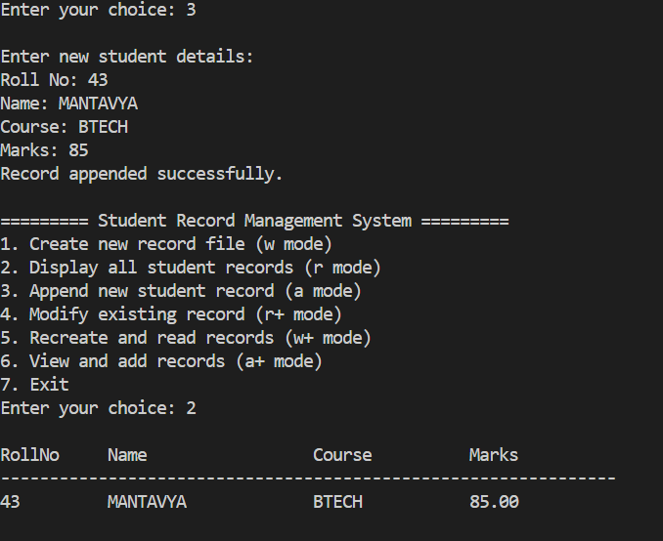
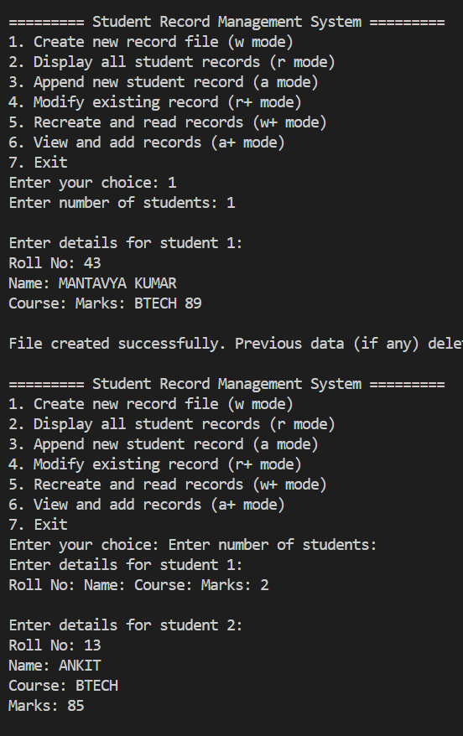
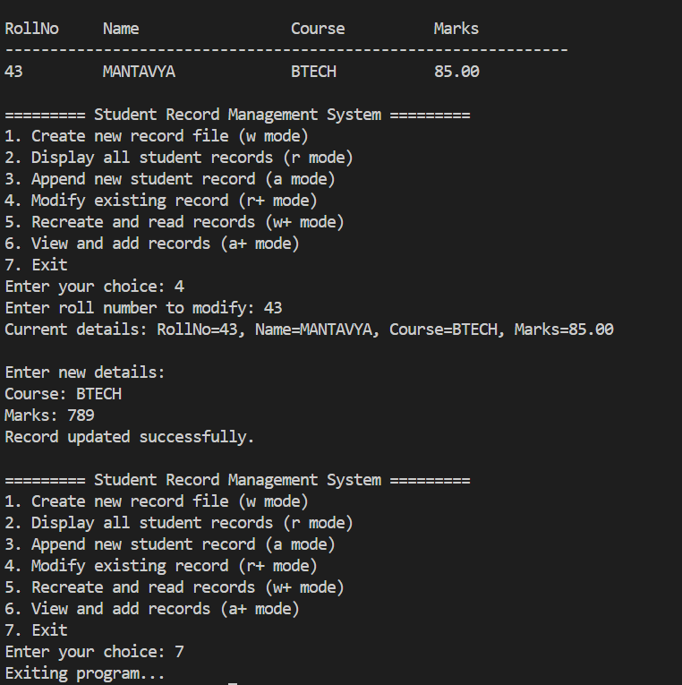

THANK YOU

